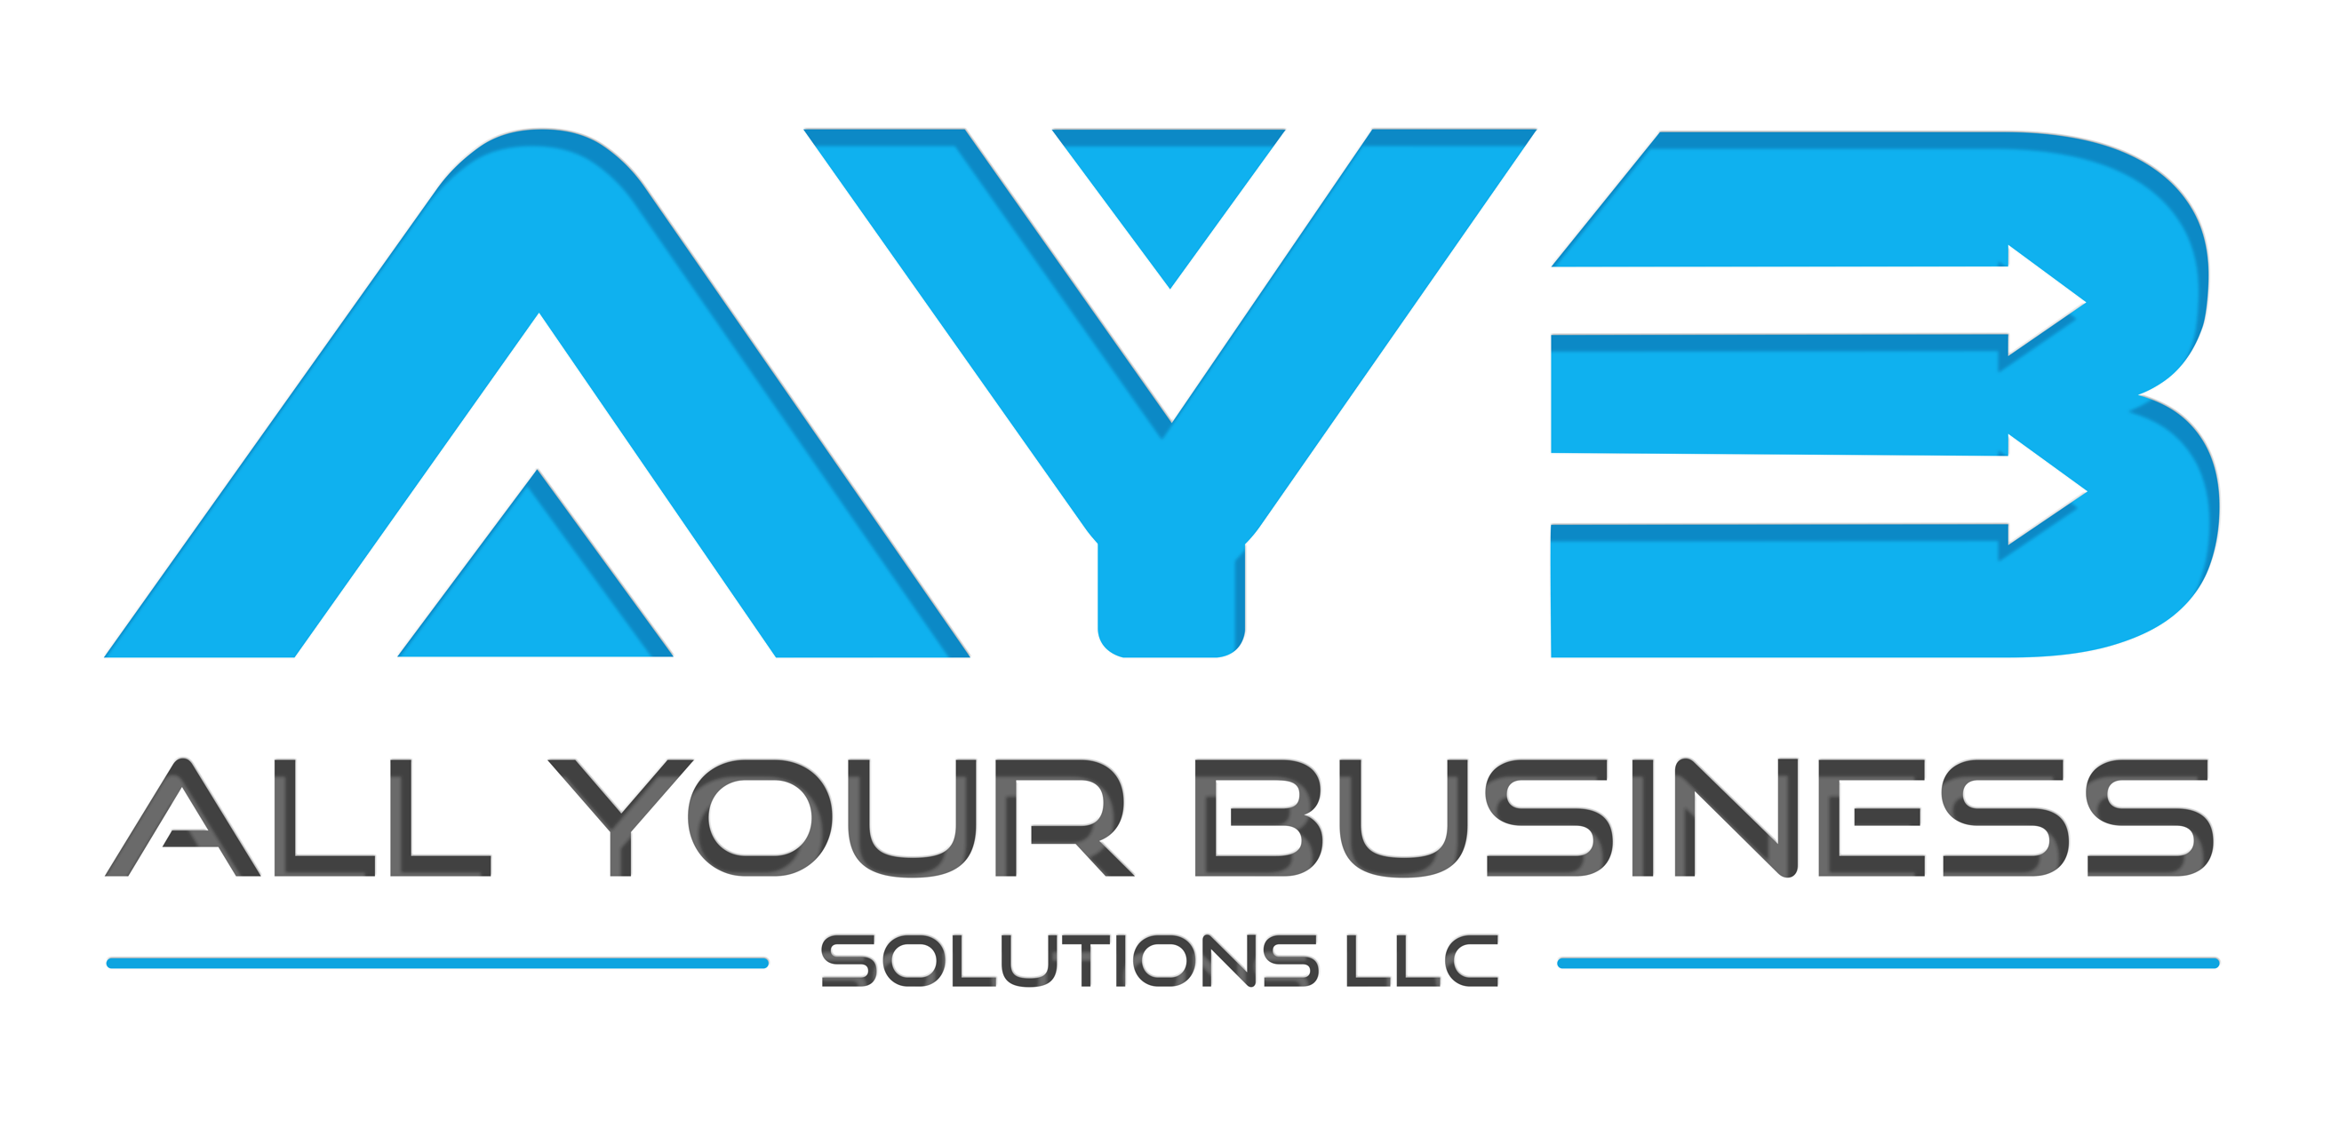

TAX PREPARATION

Preparing and planning for taxes is often a stressful and complicated endeavor for most people.

**NEED HELP WITH**  
**Unfiled Returns?   Amended Returns?   IRS Tax Debt Settlement?**

**Business & Personal Tax Services:**

**Our firm offers professional preparation of all federal, state, and local tax returns at competitive, affordable rates.**

|  |  |
| --- | --- |
| /var/folders/jx/cwwnvy211wz0td4c42rn1nj00000gn/T/com.microsoft.Word/WebArchiveCopyPasteTempFiles/5_01.png**Free Initial Consultation** Solve your IRS tax problem today! Contact us and set up your free, no obligation consultation. | /var/folders/jx/cwwnvy211wz0td4c42rn1nj00000gn/T/com.microsoft.Word/WebArchiveCopyPasteTempFiles/6.png**Late Returns? No Problem** We will help you get caught up even if you have missing records or don't have a clue where to begin. |
| /var/folders/jx/cwwnvy211wz0td4c42rn1nj00000gn/T/com.microsoft.Word/WebArchiveCopyPasteTempFiles/2_05.png**IRS TAX Liens** If the IRS put a lien on your property or sent you a Notice of Lien, call us today or click below for relief | /var/folders/jx/cwwnvy211wz0td4c42rn1nj00000gn/T/com.microsoft.Word/WebArchiveCopyPasteTempFiles/3.png**Wage and Bank Levy** If the IRS took Money out of your bank account or out of your paycheck, call us today or click below for relief. |
| /var/folders/jx/cwwnvy211wz0td4c42rn1nj00000gn/T/com.microsoft.Word/WebArchiveCopyPasteTempFiles/1_04.png**Individual Tax Returns** Simple or complex, we can do it promptly and do it right. And for a reasonable price, of course! | /var/folders/jx/cwwnvy211wz0td4c42rn1nj00000gn/T/com.microsoft.Word/WebArchiveCopyPasteTempFiles/4.png**Business Tax Returns** Your Sole Proprietor, LLC, Partnership, or Corporation tax return is no problem for us to prepare. |

Preparing your own tax return can be extremely difficult with today's complex tax code and may often leave you with more questions than answers.

These days, the majority of people and small businesses use a professional tax preparer to assist with the preparation of taxes. Even if you are just filing a simple return, the rules may change from year to year and it is easy to overlook these changes and submit an incorrect return. By doing your taxes yourself, you may also end up overlooking deductions and credits.

At AYB Solutions LLC, we have the expertise that is needed to help you file your returns while also helping you to minimize your tax liability with careful planning.

**Tax Preparation in Orlando  
Our tax preparation services include:**

* Individual Tax Preparation
* Business Tax Return Preparation
* Partnership & Corporate Tax Preparation
* Out-of-State Returns
* Business Start-Ups

AYB Solutions LLC can also help with our extensive tax planning services.

**Tax Planning & Education**  
Tax planning is essential to helping you successfully and legally reduce the amount of your tax liabilities. In addition to making sure that your business is tax compliant, we also can suggest tax saving strategies that will maximize your after-tax income.

We offer tax and education planning to assist start-ups, as well as, established businesses. We will provide you with a complete list of the most commonly overlooked deductions so that you can limit your tax liability for the following year.

**We’ll also assist you with tax planning by:**

* helping you to defer income so that you can save money now and pay less taxes in the future
* lower taxes on your income so that you can keep more of your earnings
* lower taxes on your estate and gifts so that the beneficiaries can keep more of what you have given
* lower taxes on investments and retirement distributions so that you can maintain your lifestyle and much more.

If you own a small business in Orlando or need help with individual taxes, working with a professional tax planning service can help save you more money. AYB Solutions LLC offers the expertise that you need to save on your taxes at affordable prices.

**Tax Resources**  
Here are some links to help you learn more about FL taxes:

* [Tax Information for Individuals - Internal Revenue Service](https://www.irs.gov/individuals)
* [Business Taxes - Internal Revenue Service](https://www.irs.gov/businesses)

If you'd like to receive more information about our Orlando tax preparation and planning services, please call us at (407) 749-1120 or contact us.